GETTING DOWN TO BUSINESS… Social Studies and Science Cross-Curricular Project
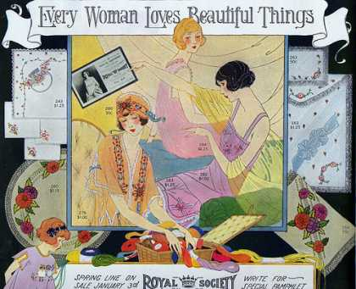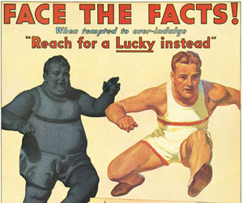
Description:
The Roaring ‘20s in the U.S. gave birth to the culture of consumerism that today moves the world’s economy. You are to capitalize on this culture by creating, marketing and managing a small business around a new invention that you design.
Procedure/Calendar:
WEEK | IN CLASS TOPICS | RESPONSILIBILTIES (to turn in by end of week)
March 10-14 | *Lessons on Economy and Business  *Marketing Techniques  *Blog “How-To” | *Ideas for invention  *Blog design and layout (“company webpage”)
March 17-21  1st Quarter | *Prospectus “How-To”  *Loans, Bonds, Stocks, Insurance… Risks and Benefits of each  *Psychology of Marketing (and its evolution) | *Invention prototype  *Finalize blog (ready to be released to the public)  *Balance sheet (assets and liabilities)  *Prospectus for “1st Quarter”  *Reflection #1  *Meeting notes
March 24-28  2nd Quarter | *Buying on credit  *The marketplace: then and now  * Supply/Demand  * Government and the Economy | *Blog Upkeep: advertisement of product and keeping stakeholders informed  *Invention production cost analysis  *Prospectus for “2nd Quarter”  *Reflection #2  *Meeting notes
March 31- April 4th  3rd Quarter | *Competition in the marketplace  *Causes of the “Great Depression” | *Blog Upkeep: advertisement of product and keeping stakeholders informed  *Prospectus for “3rd Quarter”  *Reflection #3  *Meeting notes
April 7-11  4th Quarter | *Business management  *The New Deal and post-Depression era: capitalism vs. socialism  *A special meeting | *Blog Upkeep: advertisement of product and keeping stakeholders informed  *Prospectus for “4th Quarter”  *Ideas for future of the company  *Reflection #4  *Meeting notes

