Getting Down to Business… 11th Grade Social Studies/Science Project
Company Website/Blog Rubric
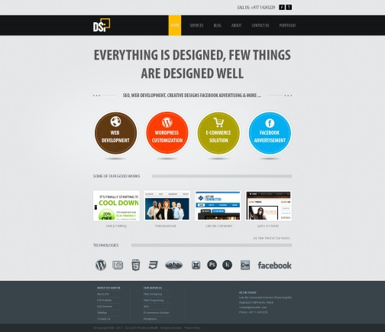
Your company website is a very important tool, both for selling your idea and for keeping your investors informed. Make sure to employ the “4 P’s” of marketing along with the “4 C’s” to convince people that your product is needed and desired in the market.
Item | Point Value
The company name, logo, slogan (optional) and your product are the visual focal points of the website. | 5
Your message lets people know:  - How your product will help them  - Why they should choose you over others  - Why they should invest | 15
Your design/layout lets people know:  - How your product will help them  - Why they should choose you over others  - Why they should invest  NOTE: Yes, these are the same! But this is done visually, whereas “messaging” is done through words. | 15
The website is “user-friendly”- all interaction is done easily (links to other pages, buttons, etc.). | 5
The website includes a “history” of your company and description of the product. | 5
The text is concise and to the point, but options are provided for users who want to read more. Important phrases, ideas, etc. should stick out from the rest of the text. | 5
Use colors and other marketing techniques appropriately and according to the audience you are trying to attract. | 5
It is evident that the “4 P’s” (price, product, promotion, and place) and the “4 C’s” (consumer, cost, communication, convenience) have been taken into consideration in the marketing of your product. | 10
The website is updated frequently and includes a prospectus at the end of each quarter (Friday). | 10
TOTAL | 75

